

Benefits Team 1

November 14 2022 | Notification Letters Version 1.0

Revision History

| Date | Version | Description | Author |
| --- | --- | --- | --- |
| 9/30/22 | 1 | Product Debut | Jacob Worrell |

Table of Contents

1 **Notification Letters Overview**4

2 **User Access** 4

3**Navigation** 4

4 **Functionality** 6

5 **Major Issues and Error Messages** 10

5.1 Subheader (as many as needed) 12

## 1. Product Overview

The Notification letter tool is currently a feature in the Claims Status Tool, but eventually will become a standalone product. It allows veterans to download decision letters related to claims they have filed. Future versions may expand the types of notification letters available for download.

## 2. User Access

Users will need to be logged into the site AND have a closed claim on file to have access to notifical letters.

## 3. Navigation

**Direct URL: https://va.gov/track-claims/your-claims-letters**

Or, most veterans will likely navigate starting at the VA.gov homepage. They will need to click “chick your claim or appeal status” in the “Disability” section.

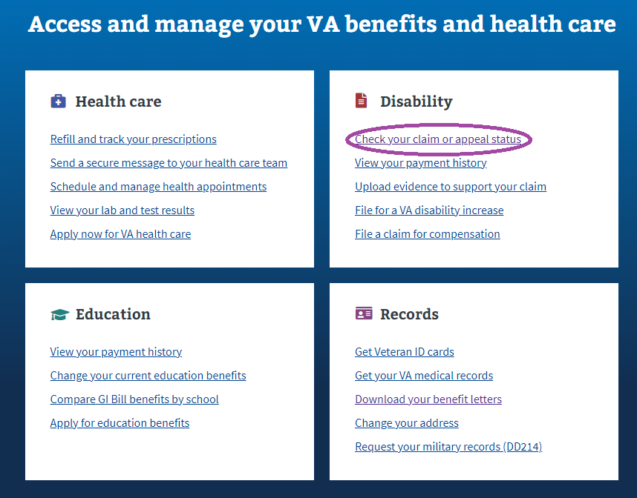

Veterans will then need to click on “View Details” on a claim that is **CLOSED**

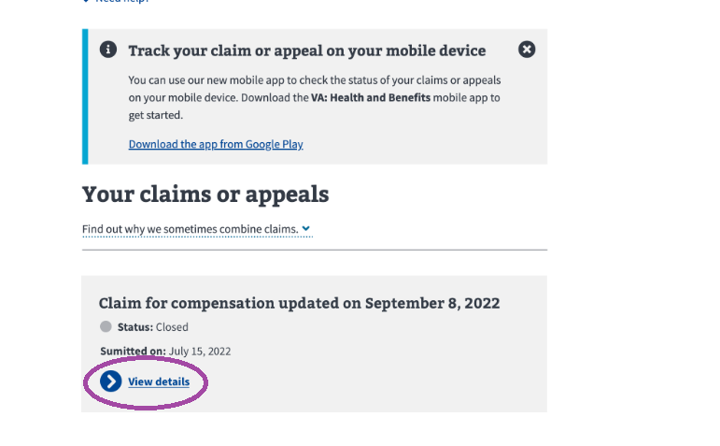

From within a CLOSED claim’s details section, veterans must then click the “Get your claims letters” link.

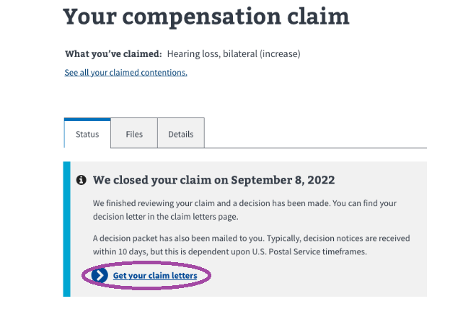

## 4. Functionality

Within the Notification Letters section, a veteran can click on one of the “Download letter” links and download their notification letter.

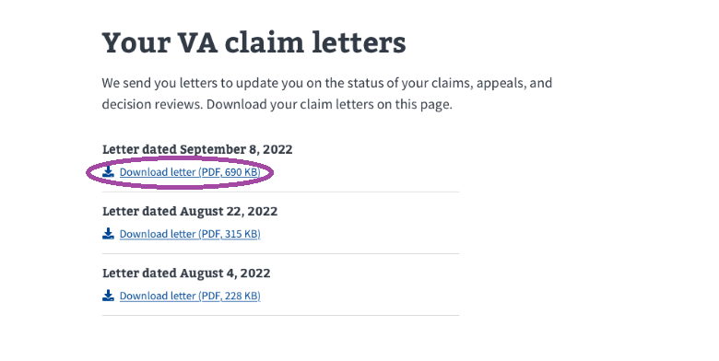

Once a veteran clicks a “Download letter” link, behavior can be browser and user setting specific. The letter will be downloaded immediately or come up as a preview in a browser window.

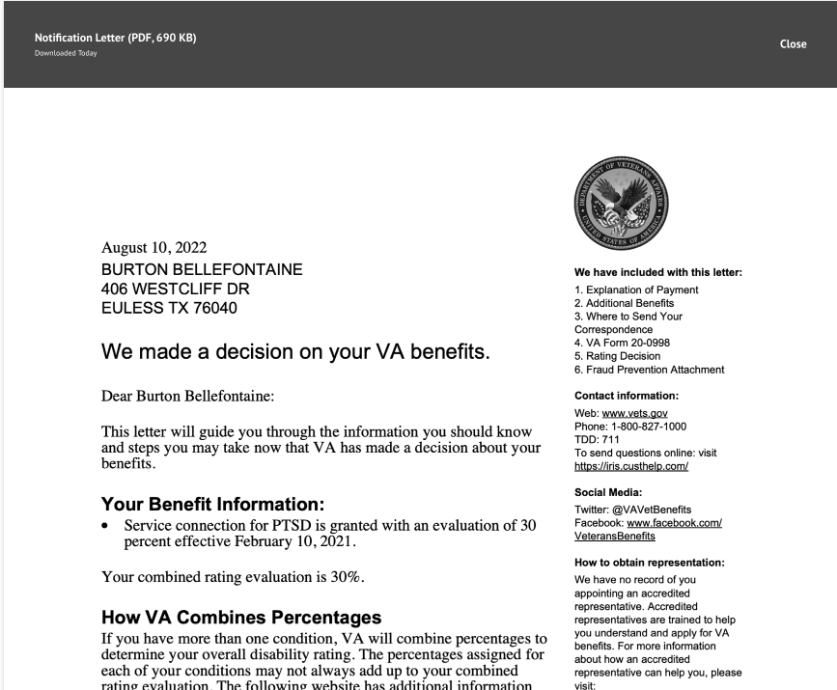

## 5. Major Issues and Error Messages

More details to come, but we expect to use the standard VA.gov error messaging approach for failed application loads.

2